**TRANSMITTER AND RECEIVER:**

The FlySky FS-i6 is a great low cost entry level 6-channel 2.4 GHz Transmitter and Receiver that uses solid and reliable Automatic Frequency Hopping Digital System (AFHDS) spread spectrum technology. The programming is simple to use.  comes with a FS-iA6 6-channel receiver.

Features :

* Entry level 6 channel 2.4GHz radio with telemetry capability
* Dual Rate/Trims/Gear/Flap/Gyro Gain Adjust/Flight Mode/Throttle Hold/Hover Pitch Switches
* Easy to use Programming & Navigation Buttons
* Supports Heli/Standard Wing/Elevon/V-Tail
* 20 Model Memory
* 8 Character Model Name
* Trainer and charging ports
* Backlit LCD Screen displays real-time transmitter and receiver voltage
* 4 Stick Mode Selectable
* Mode 2
* Comes with receiver

Specifications (FS-i6**):**

* No. of Channels: 6 Channels, Model type: Glider/Heli/Airplane, RF Range: 2.40-2.48GHz, Bandwidth: 500KHz, Band: 142, RF Power: Less Than 20dBm, 2.4ghz System: AFHDS 2A and AFHDS, Code Type: GFSK, Sensitivity: 1024, Low Voltage Warning: less than 4.2V, DSC Port: PS2;Output:PPM, Charger Port: No, ANT length: 26mm*2(dual antenna), Weight:392 gm, Power: 6V , Size: 174 x 89 x 190 mm(LxWxH).

Specifications (FS-iA6):

* No. of Channel: 6, Frequency Range: 2.4055--2.475GHZ, Band Width Number: 140, Transmitting Power: ≤ 20dBm, RF Receiver Sensitivity: -105dbm, 2.4G Mode: The second generation of an enhanced version of the automatic FM digital system, Encoding: GFSK, Antenna Length: 26mm * 2 (dual antenna), Input Power: 4.0-6.5V DC, Dimension: 47 x 26.2 x 15mm, Weight: 14.9g, Color: Black, i-Bus Interface: Yes, Data Acquisition Interface: Yes, Model Type: Airplane / Glider / Helicopter

**RECEIVER:**

The FS-R6B Flysky 2.4ghz 6 Channel Receiver is used. **It Requires 4.8-6 Volts For Working. FS-R6B Flysky 2.4 ghz 6ch Receiver Has 3 Pins Which Are Vcc, Ground, And Signal. FS-R6B Flysky 2.4 ghz 6ch Receiver For Rc FS-CT6B TH9X Can Be Powered Using Ubec Or 4.5-6.5v Battery.**

Features :

1. Item Name: FS-R6B Receiver
2. Brand Name: Flysky
3. 100% Brand New
4. RF power: less than 20DBm
5. modulation: GFSK
6. Code type: PCM
7. Sensitivity: 1024
8. Low voltage warning: LED

#### **Specifications :**

#### **Model: FS-R6B**

#### **No. of Channels:6**

#### **Encoding: GFSK**

#### **RF Range: 2.4Ghz**

#### **Operating Voltage: 3.3-5v**

#### **Control Distance: 300m**

#### **Low Voltage Alarm: LED**

#### **Antenna Length(mm): 26**

#### **Color: Black**

#### **Weight: 25gm**

#### **, Dimensions(mm )(LxWxH): 45x23x23**

#### 

|  |
| --- |
|  |

**MOTOR:**

This DYS High-Quality D2822 1450KV brushless out runner motor specifically made to power Quadcopters and Multirotors. It is a 1450kV motor

Features :

1. The steel design is capable of withstanding competitive conditions.
2. Lightweight design makes them suitable for a wide range of Quadcopter and Hexacopter Frames.
3. Compact size.
4. Offers great performance and value for money.
5. Smooth throttle response for best RC experience.

Specifications:

1. Model:D2822
2. Compatible Lipo batteries: 2S~3S
3. Motor KV(RPM/V): 1450
4. Shaft Diameter(mm): 3.17
5. Shaft Length(mm): 10
6. Maximum Power(W): 160
7. Compatible Propellers Size(inch): 8~10
8. Required ESC(A) : 30
9. Width(mm): 28
10. Height(mm): 37
11. Weight: 42gm

**ELECTRONIC SPEED CONTROLER:**

30A BLDC ESC ELECTRONIC SPEED CONTROLLER can drive motors which consume up to 30A current. It works on 2S-3S LiPo batteries. It has an onboard BEC which provides regulated 5V(2A max draw) to power the flight controller and other onboard modules. It can be used to control our brushless motors with a 2S-3S LiPo .

Features and Specifications:

* MODEL: STANDARD 30A BLDC ESC ELECTRONIC SPEED CONTROLLER
* WEIGHT: 23g
* DIMENSIONS: 45 x 24 x 9 mm(LxWxH)
* Color: Yellow/Red(Depends on Availability)
* CURRENT (A): 30A
* BEC: 3A
* Li-Poly: 2-3
* Ni-Mh/Ni-CD: 4-10 Ni-Mh
* CONSTANT CURRENT: 30A Max 40A<10s
* Li-Poly 2-3 CELLS; Ni-MH 4-10 CELLS Auto Detect
* Break On/Off
* Auto Low BATTERY Slow down at 3.0V/cell Lipo, cut-off at 2.9V/cell lipo
* APPLICATION: Multirotors, Rc Airplanes, etc.

**LIPO BATTERIES:**

The ORANGE 11.1V / 1800mAh 3S 30C LiPo battery pack with XT60 connector is equipped with heavy duty discharge leads to minimize resistance and sustain high current loads. The ORANGE 11.1V / 1800mAh 3S 30C LiPo battery pack with XT60 connector have a JST-XH style balance connectors. All Orange Lithium Polymer batteries packs are assembled using IR matched cells. Orange batteries are known for performance, reliability and optimum price also.

Features :

1. Product Type: Lithium Polymer Battery Pack
2. The Orange LiPo battery has matched resistance.
3. Good Temperature Control.
4. Minimum weight in Class

**PROPELER:**

The Orange HD Propellers 9443(9.4X4.3) DJI Carbon Fiber Black is the high-quality propellers specially designed for multi-copters. These [Orange Propellers](https://robu.in/product-category/multirotors/propellers/) are light in weight and high strength propeller has a 15° angle design at the end of the propeller to avoid whirlpool while the multi-copter is flying. They are useful in drones as well as in multi-copters.

Features :

1. Durable plastic construction provides both lightness and rigidity.
2. Very strong and lightweight.
3. Quick to release, quick to attach
4. New design propellers, with greater aerodynamic efficiency, good lifting capacity.

Specifications:

1. Model: DJI9443(9.4x4.3)
2. Material: Carbon Fiber
3. Color: Black
4. Weight(gm): 20
5. No. of Blades: 2
6. Length (inch) : 9
7. Pitch(inch): 4.3
8. Shaft Diameter(mm): 7.8
9. Total Length(mm): 230

.

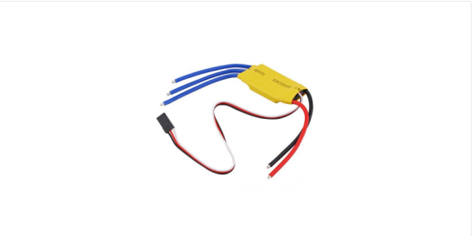ESC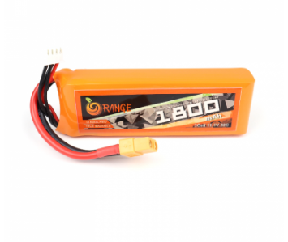Lipo Battery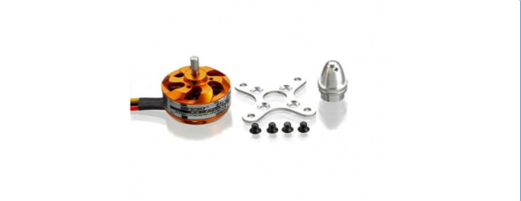Motor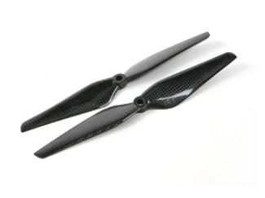Proeler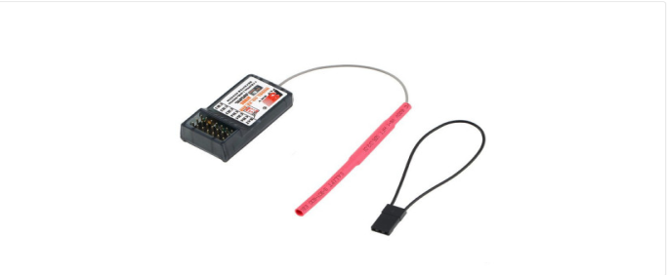Receiver

